HACETTEPE UNIVERSITY
Department of Computer Engineering

Fuzzy Modelling
Laboratory

Furkan Simsekli
5th Semester
Turkey

Academic Year 2023/2024

Exercise 7

Design a fuzzy controller. The controller has one input and one output. The range of changes for the input signal is ZX and for the output signal is ZY.

The changes of the input signal are described using three triangular membership functions. The changes of the output signal are described using three trapezoidal membership functions. The modal values of the triangular membership functions are equal: x_{m1}, x_{m2}, x_{m3}. The modal values of the trapezoidal membership functions are equal: y_{m1}, y_{m2}, y_{m3}, and the upper sides of the trapezoidal functions are equal b.

The rule base contains three rules:
R1: IF x is N THEN y is N
R2: IF x is Z THEN y is Z
R3: IF x is P THEN y is P

Determine the change in the characteristics of the controller for the following height of the intersection of the input membership function h_{1X} , h_{2X}.The height of the intersection of output membership function is equal h_{Y}.

Show in the graphic form:
- the input triangular membership functions,
- the output trapezoidal membership functions,
- the rule base
- the model of the controller,
- the characteristics of the controller

ZX = [-5, 5] ZY=[-10, 10]
x_{m1} = -2.5 x_{m2} = 0 x_{m3} = 2.5
y_{m1} = -6 y_{m2} = 0 y_{m3} = 6 b = 2

case a1)
h_{1X} = 0.25 h_{Y} = 0.50

case a2)
h_{2X} = 0.75 h_{Y} = 0.50
Solution

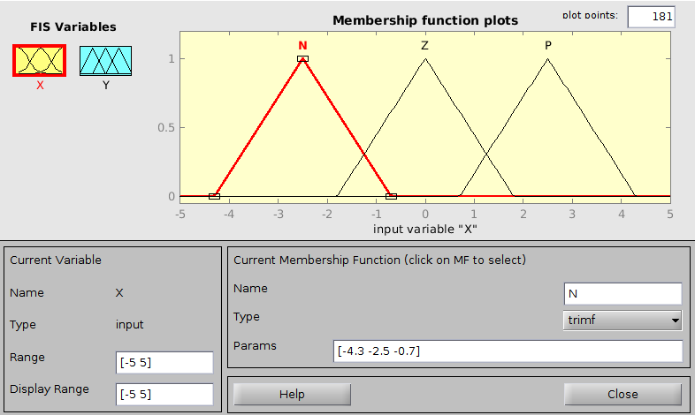
Figure 7.1: The input triangular membership functions for h_{x} = 0.25

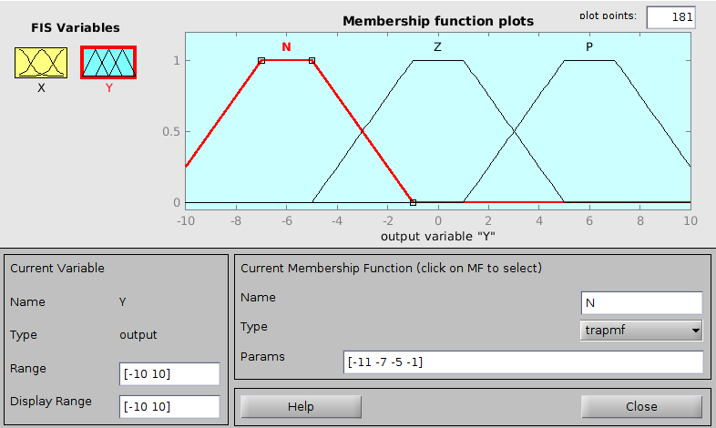
Figure 7.2: The output trapezoidal membership functions for h_{y} = 0.5

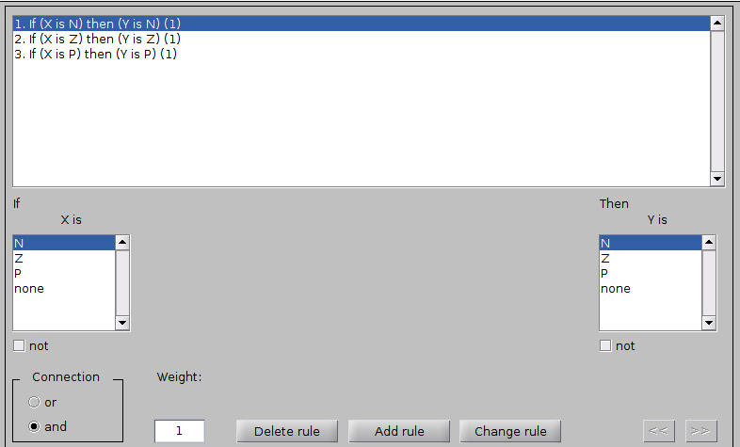
Figure 7.3: The rule base

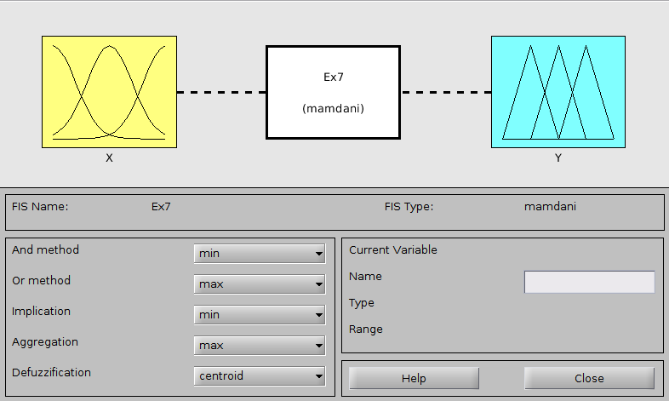
Figure 7.4: The model of the controller

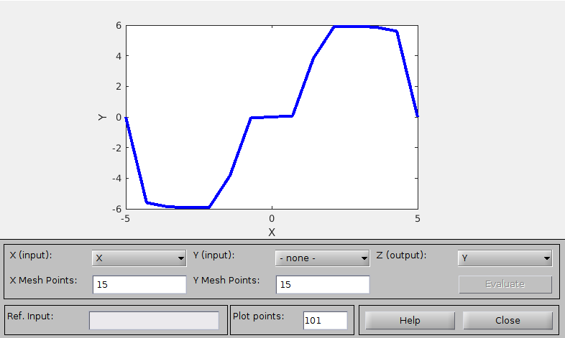
Figure 7.5: The characteristics of the controller for h_{x} = 0.25 and h_{y} = 0.5

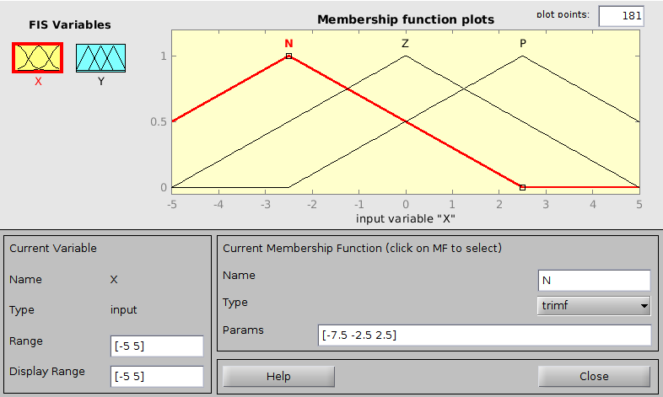
Figure 7.6: The input triangular membership functions for h_{x} = 0.75

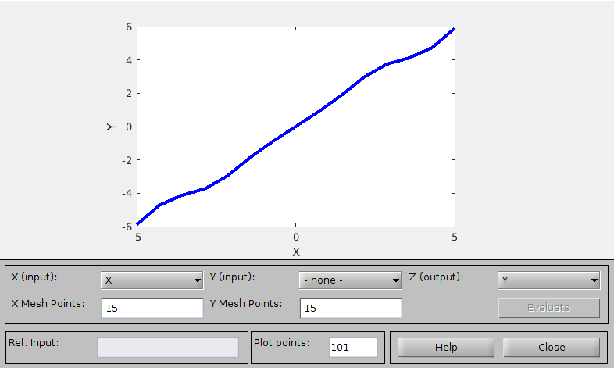
Figure 7.7: The characteristics of the controller for h_{x} = 0.75 and h_{y} = 0.5

